RT NO 213,Dt:18/12/2013
Telephone No. 0866 2455614
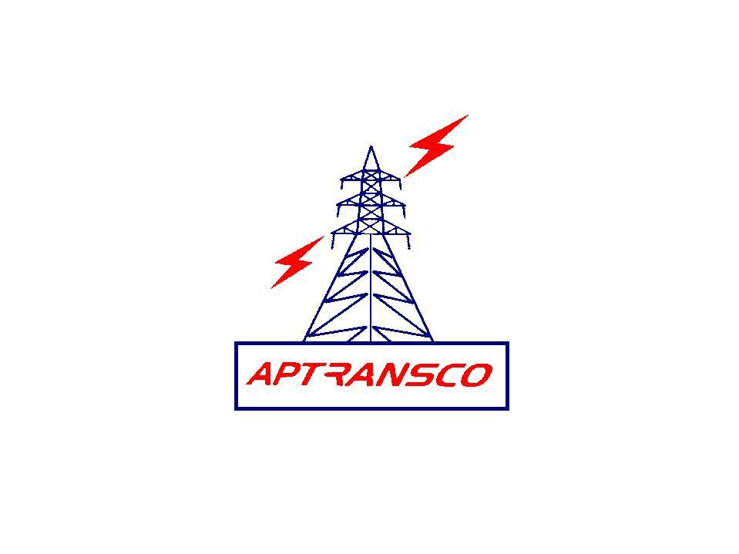
Fax: 0866 2452102

TRANSMISSION CORPORATION OF ANDHRA PRADESH LIMITED

LOCAL PURCHASE ORDER IN DUPLICATE

From To
The Chief Engineer, M/s. Notion Enterprises,
Zone, A.P.TRANSCO H.No. 3-1-248/4, Ramagiri Nilyam,
Gunadala, Kakatiya Colony, Hanamkonda,
Vijayawada WARANGAL – 506 001
Cell: 94403 47723

LPO.No.CE/Zone/VJA/Tech/AE-1/LPO.No. 29/13-14/D.No. 1300/13, Dt. 17-12-13
Dear Sir,
Sub:- A.P.TRANSCO- Zone, Vijayawada - Supply of spares for 132KV ABB make breakers for utilization at 220KV substation, Ongole - Detailed purchase order - Issued – Reg.

Ref:- 1. Ref: PPHVS ZSH 117 of M/s. ABB Ltd., Hyderabad Dt.07.11.2013
2. Your Ref: HV/NE/0058, dt.11.11.2013.
3. Lr.No.SE/TL&SS/NLR/Tech/ADE/AE-3/D.No.1717/2013,dt.04.12.2013
* * *
I, acting for and on behalf of Transmission Corporation of Andhra Pradesh Limited (herein after called the A.P.TRANSCO) accept M/s. ABB Ltd., Hyderabad offer dt. 07.11.2013 cited in the above reference for supply of spares for 132KV ABB make breakers for utilization at 220KV substation, Ongole of the above cited correspondence and subject to the terms and conditions setout in the order.
- SCOPE OF SUPPLY: This contract relates to the supply of materials as detailed in clause.2 below.

- SCHEDULE OF MATERIAL AND PRICES:

Sl.  No. | Description | Qty | Rate  Rs Ps | Unit | Amount  Rs Ps
1 | Overhauling Kit for pneumatic drive for one breaker | 2 Kits. | 84270.00 | Kit | 168540.00
2 | Overhauling Kit for ETU for one breaker (Emergency Kit) | 3 Kits | 5056.00 | Kit | 15168.00
 | Sub-Total |  |  |  | 183708.00
 | Add: VAT@5% on Sub-Total |  |  |  | 9185.40
 | Add: Freight @2% on Sub-Total |  |  |  | 3674.16
 | Total |  |  |  | 196567.56
(Rupees One lakh ninety six thousand five hundred sixty seven and paise fifty six only)

3. PRICES: The prices indicated in clause.2 above are firm and for delivery F.O.R TLC stores, Ongole and are not subject to any variation on any grounds. The prices are inclusive of freight and VAT as mentioned in clause No:2

4. TRANSIT INSURANCE: The materials shall be duly insured by you. You are responsible for settlement of insurance claims and replacement of lost/ damaged/ short supplied materials.

- SALES TAX: The VAT @5% is included in the above prices as per the rates noted above. A.P.TRANSCO Tin No. is 28760127045

- DELIVERY: The proforma invoice shall be submitted with in one week from the date of receipt of this purchase order and the materials described in clause No.2 shall be dispatched within 8 weeks from the date of confirmation of readiness of cheque from the Superintending Engineer/ TL&SS/ Nellore.

Any variation up or down in sales tax or other statutory levies or new levies introduced by the Government after placing of this purchase order shall be to A.P.TRANSCO’s account.

Provided that in cases where the delivery schedule is not adhered to by you and there are increases in sales tax or other statutory levies of new imposts after the agreed delivery dates, you shall bear the impact of these levies and if there is downward variations/ revision the A.P.TRANSCO shall be given credit to that extent.

You are also requested to dispatch the materials only on receipt of confirmation of readiness of cheque from the Superintending Engineer/ TL&SS/ Nellore.

- PENALTY: Waived

- TERMS OF PAYMENT:
100% payment will be made against proforma invoice. The proforma invoice in triplicate may be submitted immediately to the Superintending Engineer/ TL&SS/ Nellore on receipt of purchase order. The material may be dispatched after hearing the confirmation readiness of cheque from the Superintending Engineer/ TL&SS/ Nellore. Also actual dispatch details may be intimated to the Superintending Engineer/ TL&SS/ Nellore for taking steps to release the consignment in time and for arranging insurance.

- DESPATCH INSTRUCTIONS: The materials as per clause No. (2) Shall be consigned to the Asst. Executive Engineer/ TLC/ SD-I/ Ongole and dispatched by Road to the consignee freight prepaid, as indicated in clause No. (3).

All original documents shall be sent to the Superintending Engineer/ TL&SS/ Nellore for arranging payment. Copies of invoices shall be marked to the Superintending Engineer/ TLC/ Vijayawada.

A Photostat copy of the L.R shall be sent one each to the Superintending Engineer/ TL&SS/ Nellore, and the Asst. Executive Engineer/TLC/SD-I/Ongole immediately after dispatched through any reputed transporting contractors.

- PERFORMANCE GUARANTEE: Waived.

- TESTS AND TEST CERTIFICATES: Waived.

- PACKING: All the materials shall be securely packed in such a manner as to withstand rough handling during transport up to site. All the above materials shall be adequately protected before dispatch to prevent damage, corrosion and entrance of foreign matter.

- SECURITY DEPOSIT: Waived.

- LOSS OR DAMAGE: External damages or shortages that are prima facia, the result of rough handling in transit or due to defective packing will be intimated to you within a fortnight of receipt of the materials. Internal defects/ damages or shortages of any internal parts which can not ordinarily be detected on a superficial visual examination though due to bad handling in transit or defective packing or other reasons would be intimated within two months from the date of receipt of materials. In either case, the defective or damaged materials shall be replaced and shortages made good by you, free of cost to the A.P.TRANSCO.

- CORRESPONDENCE:
  - Your acknowledgement of receipt of this order and all correspondence of general or technical nature shall be addressed to this office.

  - All correspondence regarding dispatch, payments etc., shall be addressed to Superintending Engineer/ TL&SS/ Nellore with copies marked to this office.

- JURISDICTION: All and any disputes or differences arising out of or touching this order
shall be decided by courts or tribunals situated in Vijayawada. No suit or other legal proceedings shall be instituted elsewhere.

- ACKNOWLEDGEMENT: Please acknowledge the receipt of this order with your confirmation of its acceptance. The additional copy enclosed may please be returned with your signature in token of your acceptance.

Yours faithfully

CHIEF ENGINEER
APTRANSCO
VIJAYAWADA ZONE

We accept the terms and conditions of this order.

SIGNATURE OF THE SUPPLIER

Copy transmitted to the Chief Engineer/Transmission/APTRANSCO/Vidyut Soudha/Hyd-82

Copy to: -
The Superintending Engineer/ TL&SS/ Nellore
The Superintending Engineer/ TLC/ Vijayawada
The Executive Engineer/ TLC/ Ongole
The Divisional Engineer/ TL&SS/ Ongole
The Asst Divisional Engineer/O&M., O/o. the Chief Engineer/ Zone/ Vijayawada

/tmp/in/input.doc

